PROJECT REPORT

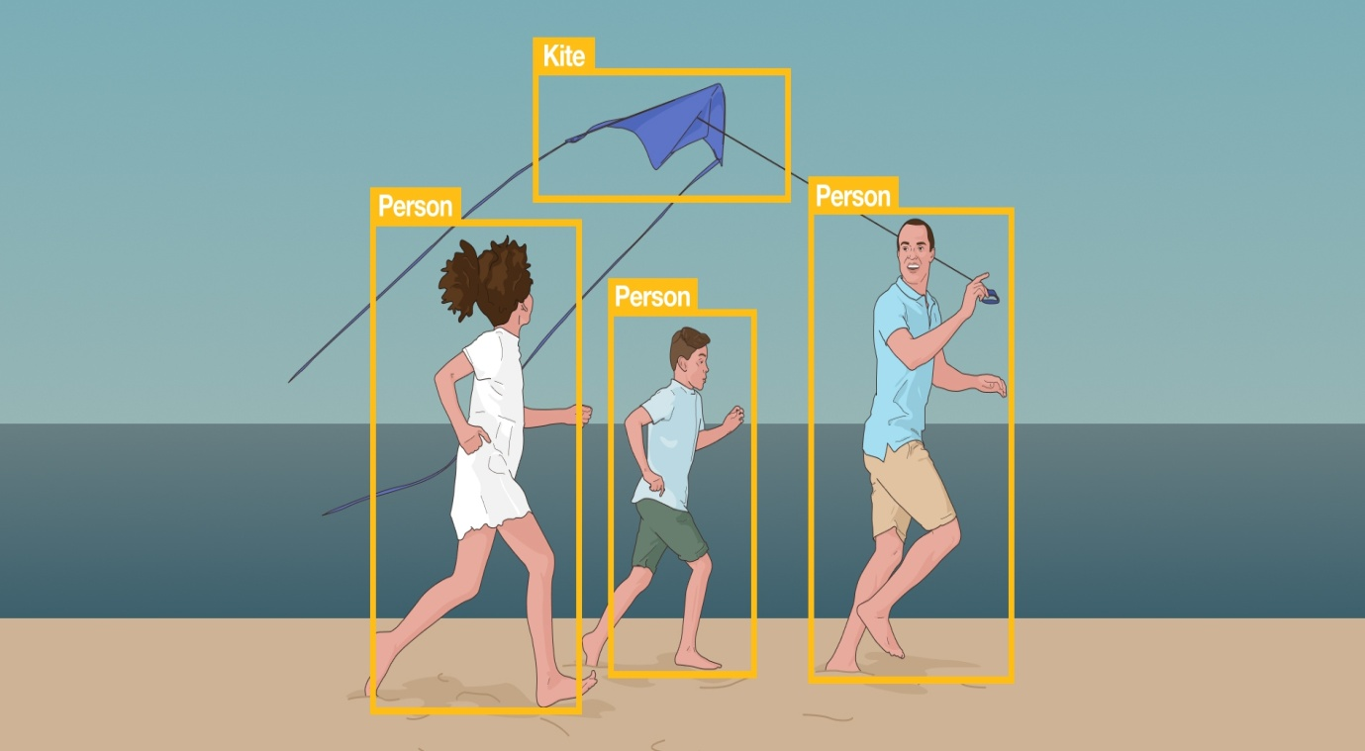

**IMAGE CLASSIFICATION**

**AND** **OBJECT DETECTION**

SUBMITTED BY-

RIYA GUPTA (A)

***PROBLEM STATEMENT***

* As we are moving forward into modern world, having more precise and detailed object recognition becomes crucial.
* One cares not only about classifying images,but also about precisely estimating the class and location of the objects contained within the images, a problem known as Object detection.
* The more complicated problem (this project), of object detection involves both classification and localization.
* Main Objectives of this project are-

1.Image Classification.

2.Dataset Preprocessing.

3.Object Detection, Segmentation,

Recognization.

4.Object Based image retrieval.

**CODE SNIPPETS AND EXPLANATION**

First, let’s import the required packages as follows:

from tensorflow import keras

import matplotlib.pyplot as plt

from sklearn.metrics import accuracy_score,confusion_matrix,classification_report

import numpy as np

import cv2

The dataset can be loaded using the code below:

(x_train, y_train), (x_test, y_test) = keras.datasets.cifar10.load_data()

The dataset used in this blog is the CIFAR-10 dataset.

Further, we can obtain the size of the train and test datasets as shown below:

x_train.shape,x_test.shape

# Normalization

x_train = x_train/255.0

x_test = x_test/255.0

The required code for the train set is as follows:

#sklearn expects i/p to be 2d array-model.fit(x_train,y_train)=>reshape to 2d array

nsamples, nx, ny, nrgb = x_train.shape

x_train2 = x_train.reshape((nsamples,nx*ny*nrgb))

The required code for the test set is given below:

#so,eventually,model.predict() should also be a 2d input

nsamples, nx, ny, nrgb = x_test.shape

x_test2 = x_test.reshape((nsamples,nx*ny*nrgb))

from sklearn.ensemble import RandomForestClassifier

Then I Create an instance of the RandomForestClassifier class:

knn=KNeighborsClassifier(n_neighbors=7)

knn.fit(x_train2,y_train)

y_pred_knn=knn.predict(x_test2)

y_pred_knn

Now evaluate the model with the test images by obtaining its classification report, confusion matrix, and accuracy score.

accuracy_score(y_pred_knn,y_test)

print(classification_report(y_pred_knn,y_test))

confusion_matrix(y_pred_knn,y_test)

from sklearn.tree import DecisionTreeClassifier

and then instantiating it to create a KNN model:

dtc=DecisionTreeClassifier()

dtc.fit(x_train2,y_train)

y_pred_dtc=dtc.predict(x_test2)

y_pred_dtc

Now, we proceed to evaluate the KNN model just the way we evaluated our previous model.

accuracy_score(y_pred_dtc,y_test)

print(classification_report(y_pred_dtc,y_test))

confusion_matrix(y_pred_dtc,y_test)

img_path='/content/bird.jpg'

img_arr=cv2.imread(img_path)

img_arr=cv2.resize(img_arr,(32,32))

#so,eventually,model.predict() should also be a 2d input

nx, ny, nrgb = img_arr.shape

img_arr2 = img_arr.reshape(1,(nx*ny*nrgb))

classes = ["airplane","automobile","bird","cat","deer","dog","frog","horse","ship","truck"]

For Final output-

ans=model.predict(img_arr2)

print(classes[ans[0]])

#RandomForestClassifier

**OUTPUT SNAPSHOTS**



